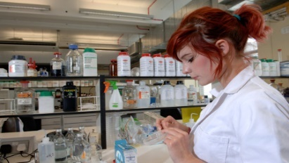
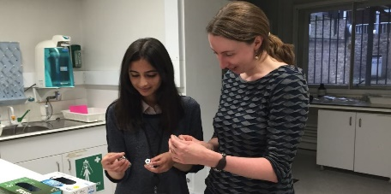
Research Placements
Nuffield research placements provide students the opportunity to work alongside professional scientists (including quantitative social scientists on the Q STEP project), technologists, engineers and mathematicians.
Projects take place in the summer holidays and must have broadly scientific or technical content, but they do not necessarily have to be in a laboratory. They might be office-based, fieldwork or they might focus on engineering, data science, social studies or computer science.
What are the benefits of a Nuffield Research Placement?
- You will get hands on experience on a real, live research project in working research and development environments.
- Exploration in a 4-6 week unique experience with professionals over the summer break.
- Build your confidence and skills – you will learn how to write a scientific report and present your work that will be useful for professional scientists, social scientist, engineers, technologists and mathematicians.
- Learn if this is the career for you and see what other careers may be available to you.
- Network – meet your peers and experts in the field that could lead to paid employment, apprenticeships and more!
- Include on UCAS applications as this is a highly viewed placement by university admissions
How do I apply and am I eligible?
- You will create an online account and complete the application on https://www.nuffieldresearchplacements.org/student/register
- You will need a personal statement and a statement from your tutor
- You need to be over 16, in year 12 and studying a level 3 course (or equivalent)
- Have at least 5 GCSE’s at level 6 or above including (Maths, English, Science)
- You must hit one of the following criteria: the first in the family to go onto university or parental income is less than £30,000 combined or have been on or are currently receiving free school meals or have been or are in local authority care.
- All travel costs for placements are reimbursed and you may also be able to claim a bursary of £100 for each week of your placement.

Students who are studying Science, Maths, IT, Engineering, Sociology or Psychology are highly advised to apply! Come along to the talk happening in Gaskells on the 05/12/18 at 12:15pm for STEM students and 1:15pm for Social Science students!

